**PROJECT – 3**

**Aim:** Integrate Grafana with Linux Server for high cpu utilization and create a graph in Grafana.

**Overview:**

This guide provides a complete, beginner-friendly walkthrough for setting up Grafana on an AWS EC2 instance to monitor high CPU usage using Node Exporter and Prometheus.

**Sections:**

1. **Prerequisites**
2. WS EC2 instance (Amazon Linux 2 or Ubuntu preferred)
3. Inbound rules allowing ports 22 (SSH), 3000 (Grafana), and 9090 (Prometheus), 9100 (Node Exporter)
4. Basic terminal knowledge

2. **Installation Steps**

Node Exporter

Prometheus

Grafana

3**. Configuration**

Prometheus Config

Grafana Setup

4. **CPU Usage Graph Creation**

Task 1: Sign in to AWS Management Console

1. Click on the Open Console button, and you will get redirected to AWS Console in a new browser tab.

2. On the AWS sign-in page,

· Leave the Account ID as default

·Now enter your username and password.

3. click on sign-in.

4.After signing in select Mumbai(Asia) ap-south-1 as AWS region.

Task2: Launching an EC2 Instance

1.Click on search bar. Enter **EC2**. Click on **EC2**.

2.Click on instances on the left side. Click on **Create instance**.

3.Enter the details:

a. **Instance Name**: Enter instance name.

b. **AMI(Amazon Machine Image)**: Ubuntu.

c. **Keypair**: Click on **Create key pair** . Enter key pair name.

d. **key pair type**: RSA

e. **Private key format**: .ppk

4.Click on **launch instance**.

5.Your instance is launched.

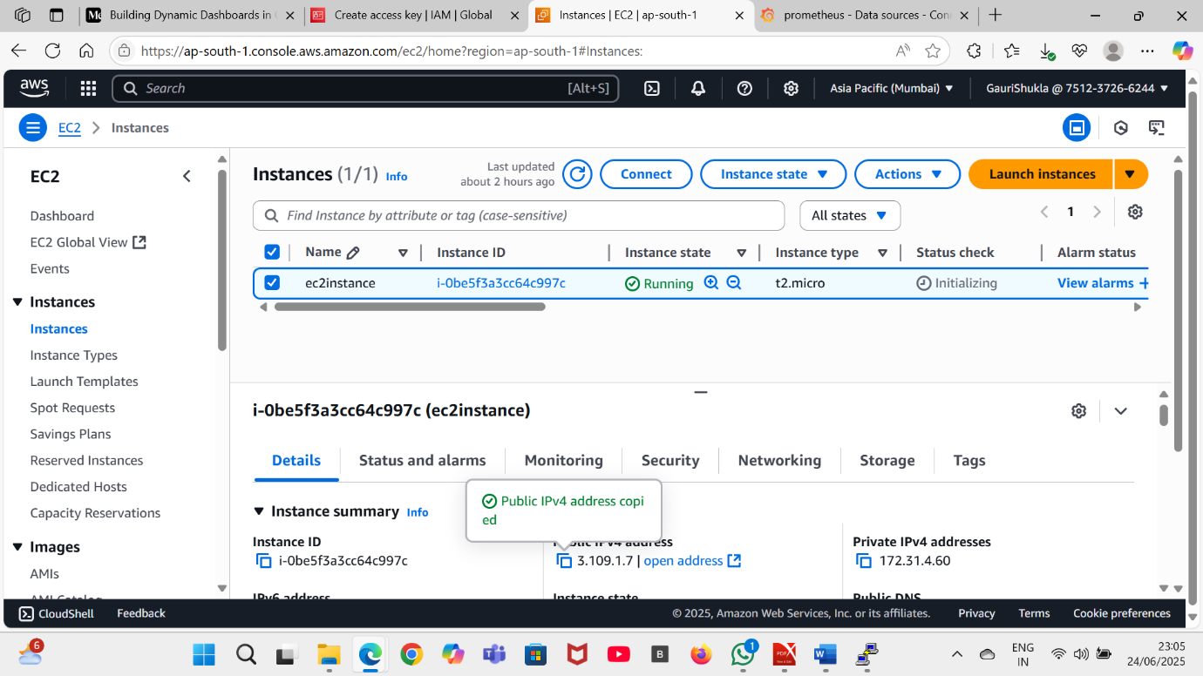

6. Go to security under security click on the link then , in inbound rules click on Edit Inbound rules : Click on add rules then select **custom TCP 3000** in **port select 0.0.0.0/.0 (Grafana**), select **custom TCP 9090** in **port select 0.0.0.0/.0 (Prometheus)**, same for **9100 (Node Exporter**).

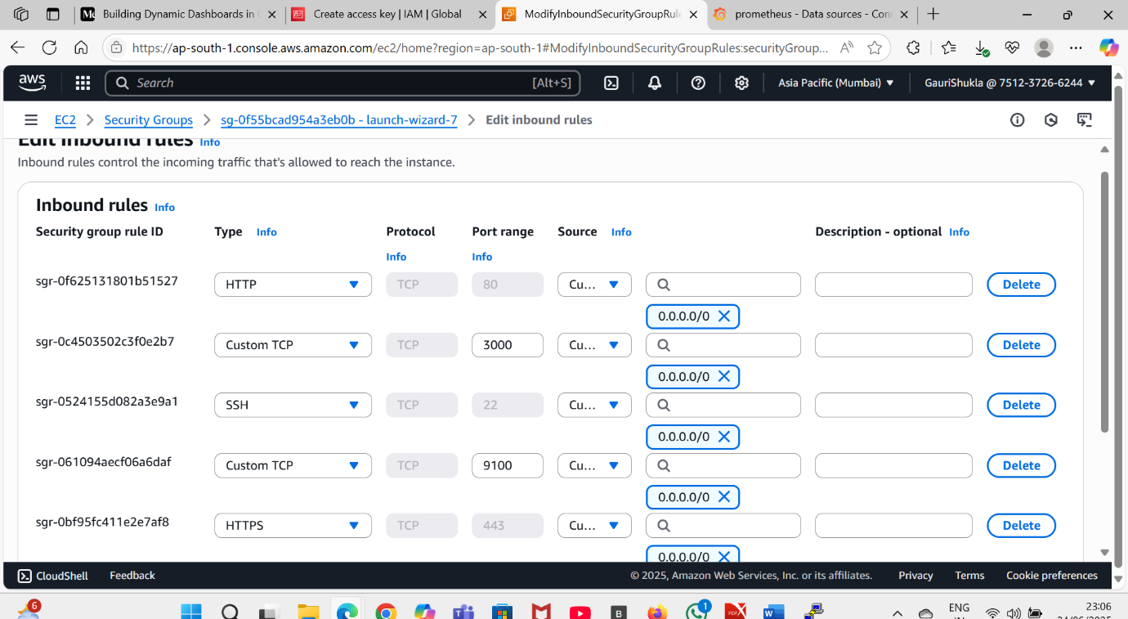

Task3: Connect your EC2 Instance using putty

1. Copy the **public IPv4 address** of your EC2 Instance.
2. Open putty.
3. Paste that **IPv4 public address** in **Host Name or (IP address).**
4. Now on the left side click on **SSH** under connection.
5. Under **SSH** select **Auth.**
6. Then browse the .ppk file. Click **open** to connect.
7. A dialog box will open click on Accept. Now enter Ubuntu in login as.
8. Now you can run your commands.

**Installation Steps**

**A. Install Node Exporter**

**cd /opt**

**wget https://github.com/prometheus/node_exporter/releases/download/v1.8.1/node_exporter-1.8.1.linux-amd64.tar.gz**

**tar -xvzf node_exporter-1.8.1.linux-amd64.tar.gz**

**mv node_exporter-1.8.1.linux-amd64 node_exporter**

**cd node_exporter**

**./node_exporter &**

**B. Install Prometheus**

**cd /opt**

**wget https://github.com/prometheus/prometheus/releases/download/v2.52.0/prometheus-2.52.0.linux-amd64.tar.gz**

**tar -xvzf prometheus-2.52.0.linux-amd64.tar.gz**

**mv prometheus-2.52.0.linux-amd64 prometheus**

**cd prometheus**

**Edit Config:**

**nano prometheus.yml**

**Edit prometheus.yml:**

**scrape_configs:**

**- job_name: 'prometheus'**

**static_configs:**

**- targets: ['localhost:9090']**

**- job_name: 'node_exporter'**

**static_configs:**

**- targets: ['localhost:9100']**

**Run Prometheus:**

**./prometheus &**

C. **Install Grafana**

**sudo apt-get install -y software-properties-common**

**sudo add-apt-repository "deb https://packages.grafana.com/oss/deb stable main"**

**wget -q -O - https://packages.grafana.com/gpg.key | sudo apt-key add -**

**sudo apt-get update**

**sudo apt-get install -y grafana**

**sudo systemctl start grafana-server**

**sudo systemctl enable grafana-server**

**Access Grafana:** http://<your-ec2-ip>:3000

1. Login to Grafana by entering admin as both username and password .

Grafana will ask you to enter new password. Enter new password. Click

Enter.

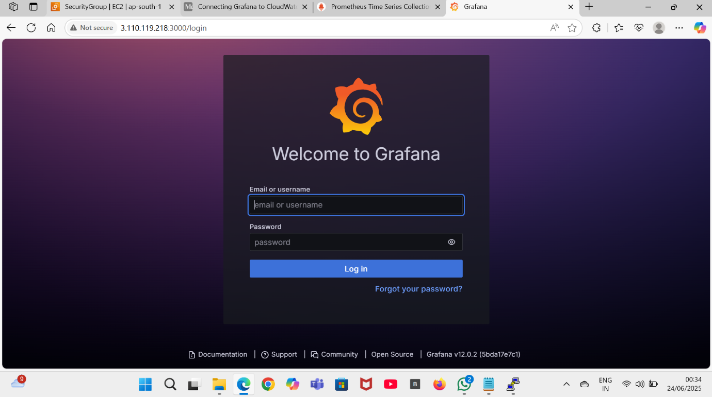

Task4: Adding Prometheus as a Data Source

1. **Add Data Source**: In Grafana, go to **left pannel>connections>data source>add data source.**

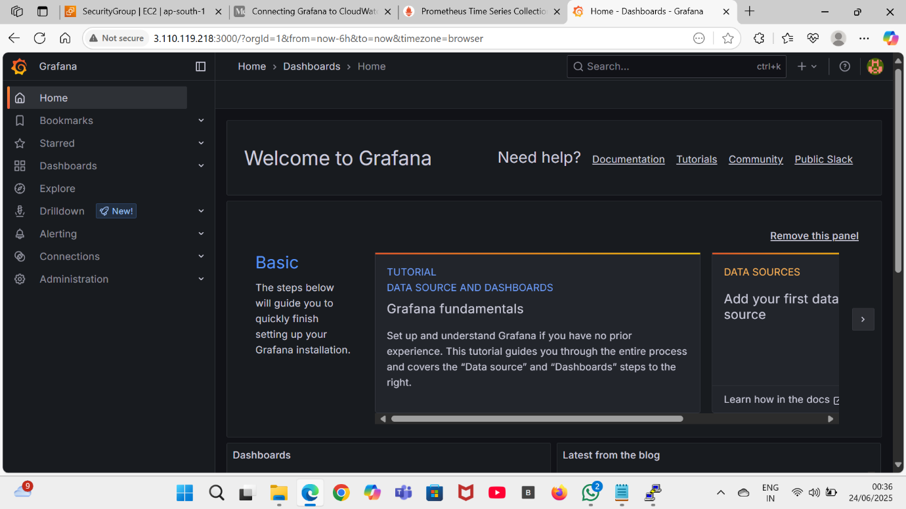

1. Select **Prometheus** from the list.
2. **Set URL to:** <http://localhost:9090>

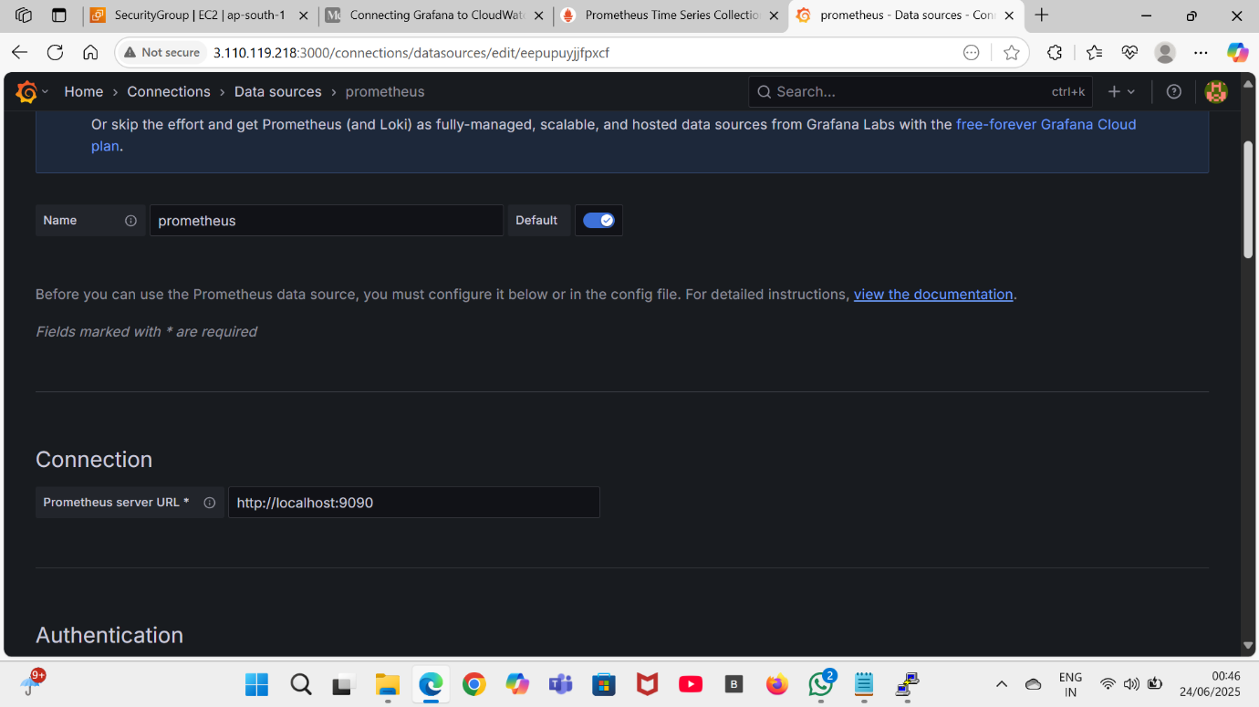

1. Click Save & Test.

Task5: Creating a Dashboard for EC2 Metrics

1. **Create Dashboard**: Click on the Dashboards icon in the sidebar and select New.

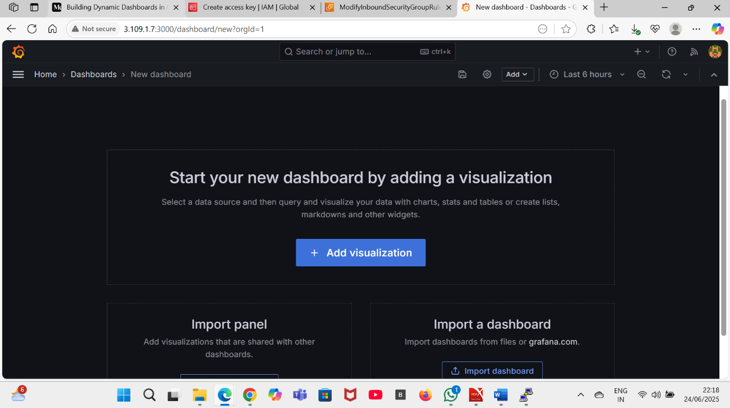

**Add Panels**: Click Add visualization. In query add this **node_cpu_seconds_total** now click on run queries your cpuutilization graph will appear.

1. You can see the CPU utilization graph. On the right side you can change the panel name .

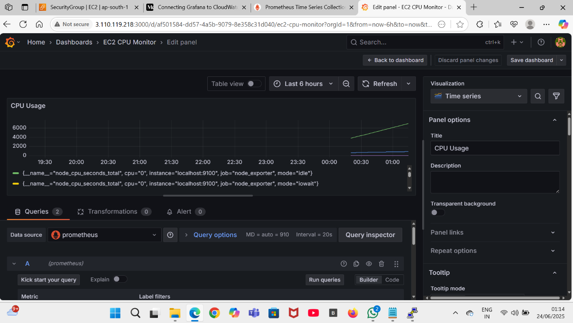

1. Now save the dashboard by clicking on save option on right corner.

**Result:**

The CPU utilization graph of linux server is created in grafana.